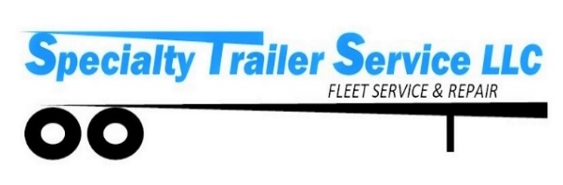

Specialty Trailer Service LLC is a sole member LLC, owned by Jerry “JD” Arnold. The LLC was established in June 2016, but JD has been operating his trailer repair business since 2003, which began in Dunn, NC and has now grown to 3 locations in 3 states. Our D-U-N-S: 11-748-2910

**LOCATIONS**

|  |  |
| --- | --- |
| **FLORIDA DIVISION**  Chris Tucker – Shop Supervisor  Ron Enoksen – Parts Manager  655 McCue Road  Lakeland, FL 33815 | **GEORGIA DIVISION**  Robert Free – Shop Supervisor  2776-B Hamilton Mill Rd  Buford, GA 30519 |
| **NORTH CAROLINA**  Randy Hall – Shop Supervisor  5899 US-70 E  La Grange, NC 28551 | **BILLING / MAIN OFFICE**  Amy Arnold or Liz Justiss  4260 US Hwy 92 E  Plant City, FL 33566 |

**SERVICES**

* FHWA Annual Inspections, Brakes & DOT
* Shop and On-Site scheduled Maintenance & Repairs
* On-Site Damage Assessment and Recovery
* Complete repair facility - floors, doors, walls, roofs, and undercarriage. We handle it all.
* Authorized Distributor & Installer for Aero, Conestoga & Roland Curtains
* No charge for service calls within a 10-mile radius of shop, during business hours (M-F 8a -5p). Beyond 10 miles, it is $3.00 per mile and minimum 2 hr. service call
* After Hours (Before 8am or after 5pm &/or Weekends) – All service calls have two-hour minimum plus mileage at $3.00 per mile

**LABOR RATE**

Trailer Repair Rate - $95.00 per hr.

We are a flat rate shop with 1/2 hr. minimum repair time.

Shop supplies & Fuel Surcharge are assessed on all invoices.

**COMPANY CONTACTS**

**Main Number 866-357-6989 or 863-583-4984**

|  |  |
| --- | --- |
| Owner – JD Arnold | Email: [jd@specialtytrailerservice.com](mailto:jd@specialtytrailerservice.com) |
| Company Administrator – Amy Arnold | Email: [amy@specialtytrailerservice.com](mailto:amy@specialtytrailerservice.com) |
| Billing Dept – Elizabeth Justiss | Email: [billing@specialtytrailerservice.com](mailto:billing@specialtytrailerservice.com) |
| Service Writer – Chris Tucker | Email: [ctucker@specialtytrailerservice.com](mailto:ctucker@specialtytrailerservice.com) |